LAB TASK-7
Name:Naqeebullah(25p-0660)
Section:BCS-1B
Question#1
#include<stdio.h>
int main()
{
int n1,n2;

printf("Name:\t\tNaqeebullah\nRoll No:\t25p-0660\nSection:\tBCS-1B\n");

printf("Enter First Number");
scanf("%d",&n1);

printf("Enter Second Number");
scanf("%d",&n2);

int quotient = 0;

while (n1 >= n2) {
int temp = n2;
int count = 1;

while ((temp << 1) <= n1)
{
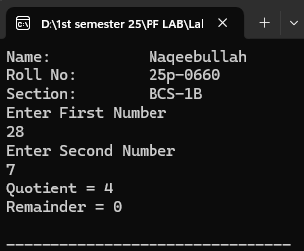
temp = temp << 1;
count = count << 1;
}

n1 = n1 - temp;
quotient += count;
}

printf("Quotient = %d\n", quotient);
printf("Remainder = %d\n", n1);
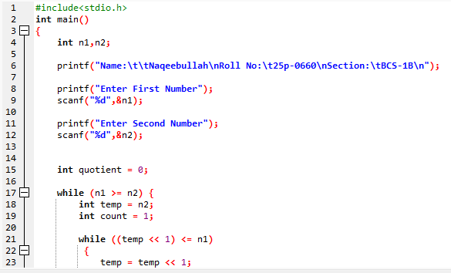
return 0;
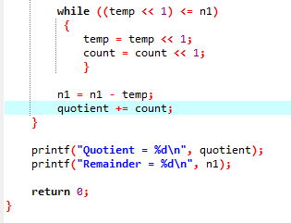
}

Question#2
#include <stdio.h>
int main()
{

int n;
int d;
int i, j, temp;

printf("Name:\t\tNaqeebullah\nRoll No:\t25p-0660\nSection:\tBCS-1B\n");

printf("Enter the size of array");
scanf("%d",&n);

printf("Enter the numbers for Array");

int arr[n];

for(i=0; i<n; i++)
{
scanf("%d",&arr[i]);
}

printf("Enter Position");
scanf("%d",&d);

d = d % n;

int s = sizeof(arr)/sizeof(arr[0]);

for(i = 0; i < d; i++)
{
temp = arr[0];

for(j = 0; j < s - 1; j++)
{
arr[j] = arr[j + 1];
}

arr[n - 1] = temp;
}

for(i = 0; i < s; i++)
{
printf("%d ", arr[i]);
}

return 0;
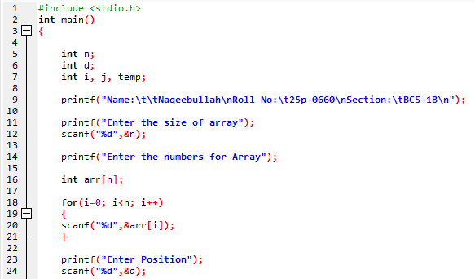
}

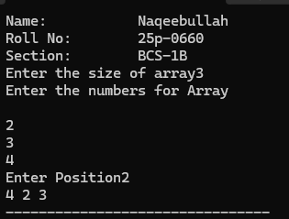
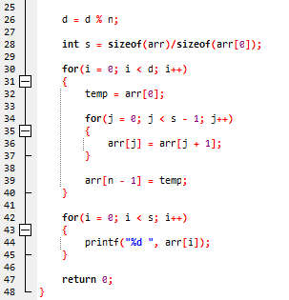

Question#3
#include<stdio.h>
int main()
{
int n,digit;
int sum=0;

printf("Name:\t\tNaqeebullah\nRoll No:\t25p-0660\nSection:\tBCS-1B\n");

printf("Enter The Number");
scanf("%d", &n);

while(n>0)
{
digit=n%10;
sum+=digit;
n = n/10;
}

printf("Sum is: %d",sum);

return 0;
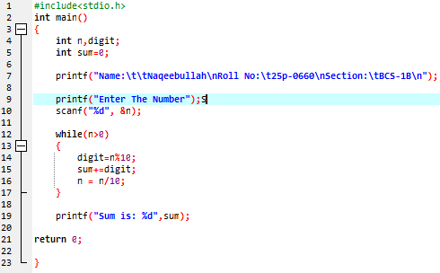
}

Question#4
#include<stdio.h>
int main()
{
printf("Name:\t\tNaqeebullah\nRoll No:\t25p-0660\nSection:\tBCS-1B\n");

int m, n, i, j;

printf("\nEnter m and n of Matrix: ");
scanf("%d %d", &m, &n);

if(m != n){
printf("Not a Symmetric\n");
return 0;

}

int array[m][n];

for(i = 0; i < m; i++)
{
for(j = 0; j < n; j++)
{
printf("Enter a[%d][%d]: ", i, j);
scanf("%d", &array[i][j]);
}
}
printf("\nOriginal Matrix:\n");

for(i = 0; i < m; i++)
{
for(j = 0; j < n; j++)
{
printf("%d ", array[i][j]);
}

printf("\n");
}
int symmetric = 1;
for(i = 0; i < m; i++)
{
for(j = 0; j < n; j++)
{
if(array[i][j] != array[j][i])
{
symmetric = 0;
break;
}
}

if(!symmetric) break;
}

if(symmetric)
{
printf("\nSymmetric\n");
}

else
{
printf("\nNot a Symmetric\n");
}
return 0;
}

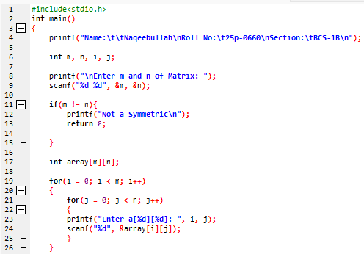

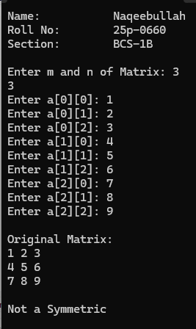
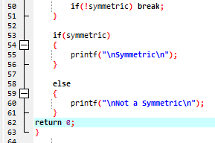
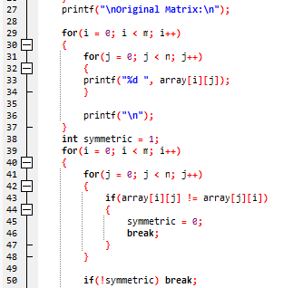

Question#5
#include<stdio.h>
int main()
{

printf("Name:\t\tNaqeebullah\nRoll No:\t25p-0660\nSection:\tBCS-1B\n");

int i,j,k,n;

printf("Enter Number of Rows: ");
scanf("%d",&n);

for (i=1;i<=n;i++)
{
for(j=1;j<=n-i;j++)
{
printf(" ");
}

for(j=1;j<=2*i-1;j++)
{
if(j==1 || j==2*i-1)
printf("*");
else
printf(" ");
}

printf("\n");
}

for (i=n-1;i>=1;i--)
{
for(j=1;j<=n-i;j++)
{
printf(" ");
}

for(j=1;j<=2*i-1;j++)
{
if(j==1 || j==2*i-1)
printf("*");
else
printf(" ");
}

printf("\n");
}
return 0;
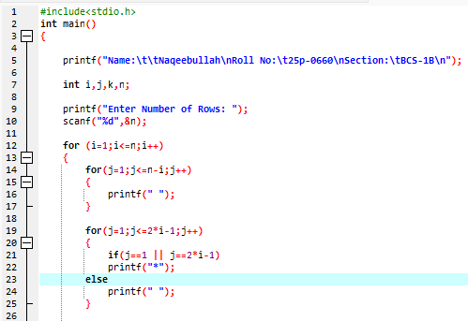
}
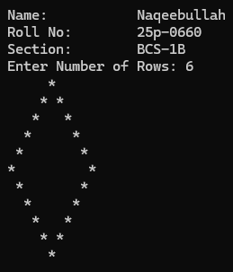
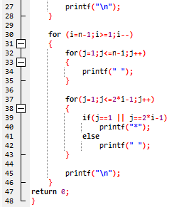

Question#6
#include<stdio.h>
int main()
{
printf("Name:\t\tNaqeebullah\nRoll No:\t25p-0660\nSection:\tBCS-1B\n");

int n,i,j,ctr;

printf("\nEnter Size of Array: ");
scanf("%d",&n);

int array[n],visited[n];

for(i=0;i<n;i++)
{
printf("array[%d]: ",i);
scanf("%d",&array[i]);
visited[i] = 0;
}

for(i=0;i<n;i++)
{
ctr = 0;

if(visited[i] == 1)
{
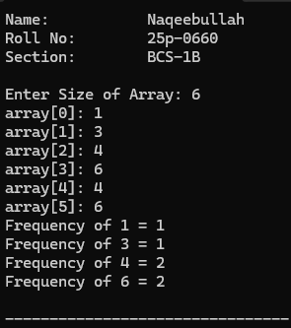
continue;
}

for(j=0;j<n;j++)
{
if(array[i]==array[j])
{
ctr++;
visited[j] = 1;
}
}

printf("Frequency of %d = %d\n", array[i], ctr);
}
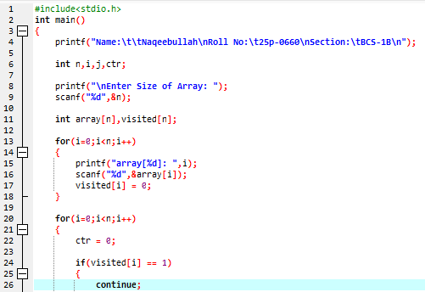
}
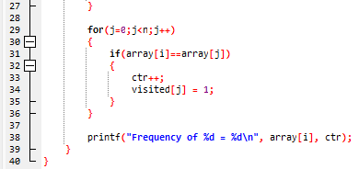

Question#7
#include<stdio.h>
int main()
{
printf("Name:\t\tNaqeebullah\nRoll No:\t25p-0660\nSection:\tBCS-1B\n");

int ma, na, mb, nb, i, j, k;

printf("\t----Matrix A----\n");

printf("Enter the rows and column: ");
scanf("%d %d", &ma, &na);

int A[ma][na];

for(i = 0; i < ma; i++)
{
for(j = 0; j < na; j++)
{
printf("A[%d][%d]: ", i, j);
scanf("%d", &A[i][j]);
}
}

printf("\t----Matrix B----\n");
printf("Enter the rows and column: ");
scanf("%d %d", &mb, &nb);

if(na != mb)
{
printf("Matrix multiplication not possible!\n");
return 1;
}

int B[mb][nb];
for(i = 0; i < mb; i++)
{
for(j = 0; j < nb; j++)
{
printf("B[%d][%d]: ", i, j);
scanf("%d", &B[i][j]);
}
}

int C[ma][nb];

for(i = 0; i < ma; i++)
{
for(j = 0; j < nb; j++)
{
C[i][j] = 0;
for(k = 0; k < na; k++)
{
C[i][j] += A[i][k] * B[k][j];
}
}
}

printf("\t---Result---\n");

for(i = 0; i < ma; i++)
{
for(j = 0; j < nb; j++)
{
printf("%d\t", C[i][j]);
}

printf("\n");
}
}

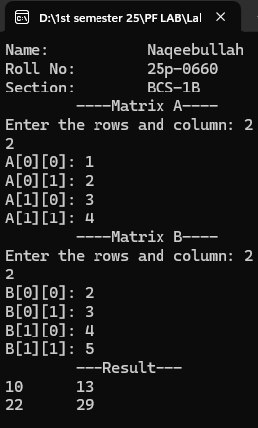
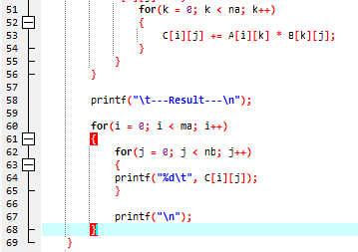
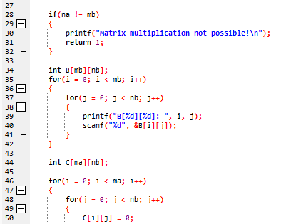
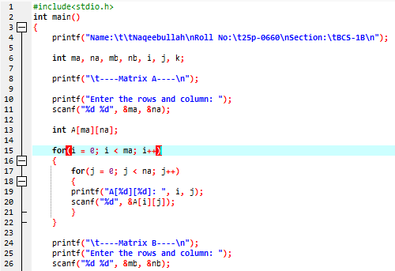

Question#8
#include<stdio.h>
int main()
{
printf("Name:\t\tNaqeebullah\nRoll No:\t25p-0660\nSection:\tBCS-1B\n");

int n, i, j, temp;

printf("Enter Size of Array: ");
scanf("%d", &n);

int array[n];

for(i = 0; i < n; i++)
{
printf("array[%d]: ", i);
scanf("%d", &array[i]);
}

for(i = 0; i < n-1; i++)
{
for(j = 0; j < n-i-1; j++)
{
if(array[j] > array[j+1])
{
temp = array[j];
array[j] = array[j+1];
array[j+1] = temp;
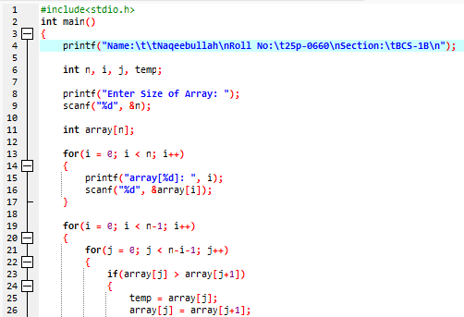
}
}
}

printf("Sorted Array: ");

for(i = 0; i < n; i++)
{
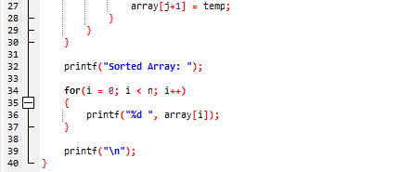
printf("%d ", array[i]);
}

printf("\n");
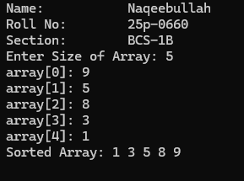
}

Question#9
#include<stdio.h>
int main()
{
printf("Name:\t\tNaqeebullah\nRoll No:\t25p-0660\nSection:\tBCS-1B\n");

int x, y, i, j;

printf("Number of Branches: ");
scanf("%d", &x);

printf("Number of Company Mobile Phones in Each Branch:");
scanf("%d", &y);

int mobileBills[x][y];

for(i = 0; i < x; i++)
{
for(j = 0; j < y; j++)
{
printf("mobileBills[%d][%d]: ", i, j);
scanf("%d", &mobileBills[i][j]);
}
}

int totalBill = 0;
int branchTotal = 0;
int maxMobileBill = mobileBills[0][0];
int maxMobileBranch = 0, maxMobileID = 0;
int maxBranchTotal = 0;
int maxBranchID = 0;

for(i = 0; i < x; i++)
{
branchTotal = 0;
printf("Total Bill for Branch X%d: ", i);

for(j = 0; j < y; j++)
{
totalBill += mobileBills[i][j];
branchTotal += mobileBills[i][j];

if(mobileBills[i][j] > maxMobileBill)
{
maxMobileBill = mobileBills[i][j];
maxMobileBranch = i;
maxMobileID = j;
}
}

if(branchTotal > maxBranchTotal)
{
maxBranchTotal = branchTotal;
maxBranchID = i;
}
printf("%d\n", branchTotal);
}

printf("\nTotal Bill: %d\n", totalBill);
printf("Branch with Maximum Total Bill: X%d = %d\n",

maxBranchID, maxBranchTotal);
printf("Highest Individual Mobile Bill: %d (Branch X%d,Mobile Y%d)\n",maxMobileBill, maxMobileBranch, maxMobileID);
return 0;
}

